Professor YU Yu Chiu, Donald.
MD(HK), FRCP(Lond), FRCP(Edin), FHKCP, FHKAM(Medicine)
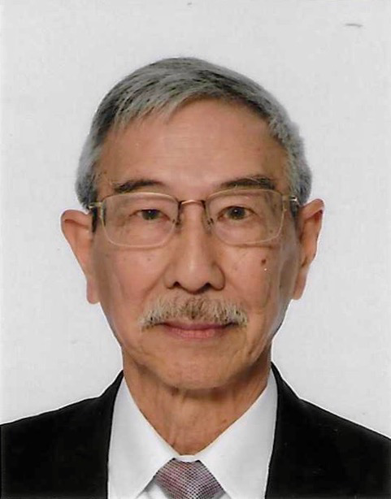

I graduated from HKU in 1960 and was awarded the Anderson Gold Medal together with the CP Fong medal in Medicine and Digby Memorial Medal in Surgery. In the early 60s Respiratory Medicine started to evolve beyond Pulmonary Tuberculosis and didactic teachings to physiological based and evidence based understanding of the respiratory diseases. Prof McFadzean in the University Department of Medicine then arranged for me to be trained in Respiratory Medicine at the Brompton Hospital in London. Before departure, I enjoyed 4 months training at the Ruttonjee Sanatorium. I was immensely enlightened and impressed by both clinical and administrative expertise plus the dedication in the care of the tuberculous patients by the two Sisters Aquinas and Gabriel and the voluntary surgical services by Dr. Kenneth Hui and Dr. Morgan Lui. It was a very enjoyable experience. At the Brompton, I was exposed to both the old world traditional chest physicians and the new turks of respiratory medicine, formulating my interest in this specialty.

I rejoined the University Department of Medicine in mid 1966. The newly formed Respiratory Unit was incorporated into the Lewis Lab formed exactly 10 years previously. Starting with one untrained lab helper plus two water displacement spirometers, the pulmonary lab developed flow-volume recordings, nitrogen washout lung capacity, carbon monoxide diffusing capacity and exercise ventilatory gas exchange with non-invasive cardiac output assessment by improvising, building these machines locally by ourselves as commercial pulmonary function machines were not available in those days. It was fortunate that my lab assistant Ah Ming proved to be industrious, diligent, eager to pursue new knowledge and techniques. He finally acquired the license of a full-fledged pulmonary function lab technician. I was privileged together with the cardiologists to be involved with the development of the intensive care unit in QMH, the second such unit in HK. Fibreoptic bronchoscopy was started in the 70’s. Before the arrival of monitors, I had to supervise the trainees with a teaching scope attached to the fiberoptic scope. The Respiratory Team introduced integrated clinical rounds with thoracic surgeons and microbiologist and radiological rounds with Prof. Henry Ngan of the radiological department to improve the training environment of our trainees. I was promoted to Senior Lecturer in 1973 and Reader in Medicine in 1977. My most treasured achievement working in University Department of Medicine was the success in stimulating and enticing Prof. WK Lam and Prof. SY So to take up the specialty of Respiratory Medicine. They had facilitated the progressive evolution and success of the Respiratory Unit in the Department of Medicine of QMH and were instrumental in the formation of the local Chest Societies and the HK Lung Foundation.
Since 1982 I entered the world of private practice. I do miss the stimulating academic exchanges, challenges and the family atmosphere in UMU. I have been awarded the chance to cherish and enjoy the teaching of medical students all these years. I was invited to be an Honorary Professor in the Department of Medicine in 2010. I started the pulmonary function lab in St. Paul's Hospital and helped the development of the intensive care in the HK Sanatorium & Hospital. Fibreoptic bronchoscopy then started to become popularised in the private hospitals since 1982. Looking back, I find this new world fascinating. This has allowed me more time to engage with my patients and their relatives to have a better communication and comprehension of their underlying ailments, palpable to their aspirations, trials and tribulations, resulting in immense satisfaction on many occasions. With the rapid evolution in Respiratory Medicine in recent years, I am indebted to our Chest Societies in organizing seminars to educate all our respiratory colleagues the up to date knowledge to enable us to deliver the best management for our patients. It is never too old to learn. I sincerely hope that our local Chest Societies will continue with this vital mission forever.

