Professor Moira M.W. Chan Yeung, MB, FRCP (Edin) (Lond), FRCPC, FACP, FCCP, FHKCP, FHKAM

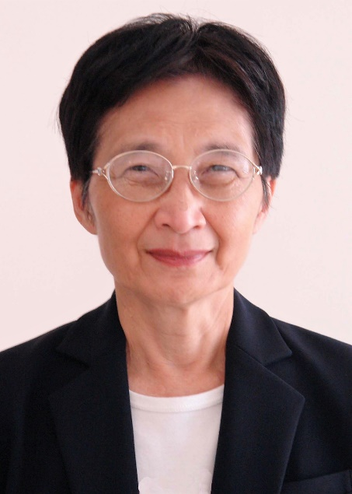

A graduate of Diocesan Girls’ School, Moira entered the Faculty of Medicine, the University of Hong Kong in 1957 with a King Edward VII Scholarship. As an undergraduate, she won several gold medals and prizes. After three years of training at the University Medical Unit, Queen Mary Hospital, she left on a Commonwealth Scholarship to the United Kingdom for further studies in 1966. In the UK she took membership examination of the Royal Colleges of Physicians of Edinburgh and London, and received research training with Professor Jack Pepys at the National Heart and Lung Institute, Brompton Hospital. Because of the 1966 and 1967 riots in Hong Kong, she and her husband left for Vancouver, BC, Canada at the completion of her postgraduate training. After another round of licensing and professional examinations in Canada, she began her academic career in earnest at the Department of Medicine, the University of British Columbia. Her main area of research was in asthma, beginning with studies of exercise induced asthma but later focused on the condition prevalent in British Columbia, occupational asthma due to Western Red Cedar (Thuja plicata). She identified the chemical compound in Western Red Cedar wood causing asthma, and worked diligently to have occupational asthma recognized as a compensable disease and for the patients who failed to recover to receive permanent disability benefits, first in Canada and later in North America. She established the Occupational and Environmental Diseases Centre, at the Vancouver General Hospital. She served on or chaired a number of research grants and advisory committees, including the Medical Research Council and Health and Welfare of Canada, the Pulmonary Disease Advisory Committee of US National Institute of Health, the International Union Against Tuberculosis and Lung Disease and the World Health Organization. Her contributions in the field of occupational asthma and occupational lung diseases were recognised by several awards, including the award for “Major and Lasting Contribution to Occupational Medicine” from the American Industrial Hygiene Association and the prestigious Distinguished Achievement Award from the American Thoracic Society.
During the course of her career, she has published over 400 peer-reviewed scientific journals. After retirement, she embarked on her second career— a researcher in history and has published a number of medical and nonmedical history books including three books on the medical history of Hong Kong. At present she is Professor Emeritus of Medicine, the University of British Columbia and Hon Clinical Professor Medicine, the University of Hong Kong.

